**BRIEF RESEARCH ON GDPR**

**(The General Data Protection Regulation)**

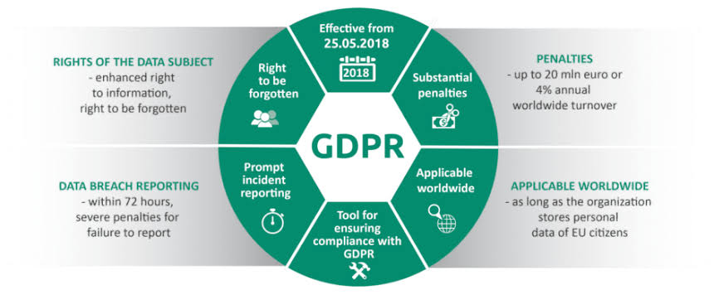

**What is GDPR?**

The GDPR was adopted in April 2016 and adds to the EU’s general policy of protecting citizen’s data. In addition to the notifications of collection and legal ramifications for misuse, there is also a requirement to obtain explicit consent, notify in cases of a hack or breach, appoint dedicated data protection officers and much more. For financial institutions, the new rules will require significant investments in compliance to ensure continuing access to the EU market. The pseudonymization of data allows firms to do some larger data analysis such as assessing average debt ratios of its customers in a particular region — that would otherwise be beyond the original purposes of data collected for assessing creditworthiness for a loan.  
  
There are many essential items in the regulation, including increased fines, breach notifications, opt-in consent and responsibility for data transfer outside the EU. As a result, the impact to businesses is huge and will permanently change the way customer data is collected, stored, and used.  
  
GDPR applies to all organizations holding and processing EU resident’s personal data, regardless of geographic location. Many organisations outside the EU are unaware that the EU GDPR regulation applies to them as well. If an organization offers goods or services to, or monitors the behavior of EU residents, it must meet GDPR compliance requirements.

**HISTORY & TAKING EFFECT OF GDPR**

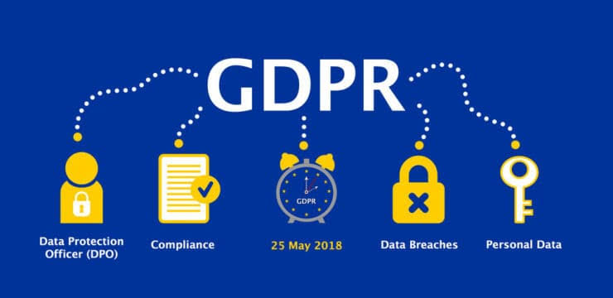

The EU's data protection laws have long been regarded as a gold standard all over the world. Over the last 25 years, technology has transformed our lives in ways nobody could have imagined so a review of the rules was needed.  
  
In 2016, the EU adopted the General Data Protection Regulation (GDPR), one of its greatest achievements in recent years. It replaces the 1995 Data Protection Directive which was adopted at a time when the internet was in its infancy.  
  
The GDPR is now recognised as law across the EU. Member States have two years to ensure that it is fully implementable in their countries by May 2018. GDPR replaces the 1995 EU Data Protection Directive, and goes into force on May 25, 2018. It also supersedes the 1998 UK Data Protection Act.

**IMPACT OF GDPR**

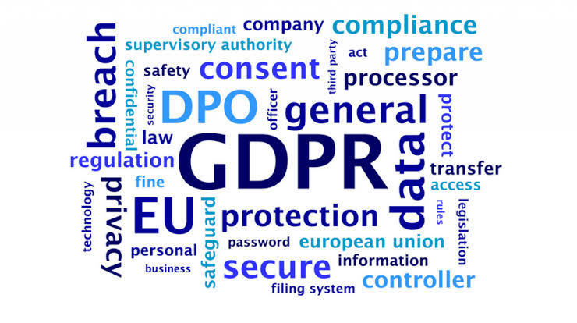

The world’s largest companies have updated their sites to comply with GDPR. Facebook launched a range of tools to “put people in more control over their privacy”, by unifying its privacy options and building an “access your information” tool to let users find, download and delete specific data on the site. The company also forced every user to agree to new terms of service, and took the opportunity to nudge them into opting-in to facial recognition technology.  
  
Apple revealed a privacy dashboard of its own. Google took a different tack, quietly updating its products and privacy policies without drawing attention to the changes. You have the power to hold companies to account as never before. If individuals begin to take advantage of GDPR in large numbers, by withholding consent for certain uses of data.

Even without user pressure, the new powers given to information commissioners across the EU should result in data processors being more cautious about using old data for radically new purposes.

**IMPACT ON BANKS**

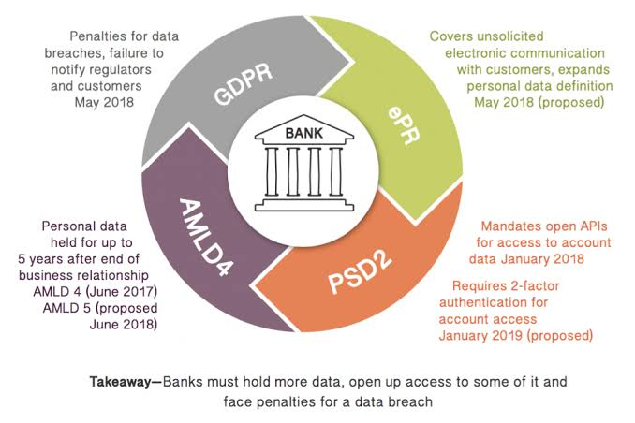

The GDPR sets a high standard for consent and defines it as “offering individuals genuine choice and control.” Under the GDPR, all of the responsibility for consent is placed upon the company.The right to data erasure, also known as the “right to be forgotten”, gives an individual the right to have their bank or financial institution completely erase their personal data, as long as there is not a compelling reason to continue processing.

The GDPR has very strict requirements if personal data is breached. Under the GDPR, a personal data breach is “any breach of security leading to the destruction, loss, alteration, unauthorised disclosure of, or access to, personal data.” Privacy by Design is an approach that implements data protection and privacy from the beginning of any business policy, procedure, or project.

**IMPACT ON CUSTOMERS**

Customers have the power to hold companies to account as never before. If individuals begin to take advantage of GDPR in large numbers, by withholding consent for certain uses of data, requesting access to their personal information from data brokers, or deleting their information from sites altogether, it could have a seismic effect on the data industry.

With the GDPR, individuals will be able to oversee what happens to their personal information: they’ll be granted access to all their personal data processed by a company, allowed to rectify, even delete it under certain conditions or request its easy transfer to another organization.

**MAJOR CHANGES FROM GDPR**

The aim of the GDPR is to protect all EU citizens from privacy and data breaches in today’s data-driven world. Although the key principles of data privacy still hold true to the previous directive, many changes have been proposed to the regulatory policies; the key points of the GDPR as well as information on the impacts it will have on business can be found below.

There is an increased territorial scope – it applies to all companies that process personal data of people residing in the union, regardless of the company’s location.

**OPPORTUNITIES**

GDPR answers the need for updated legislation in the face of rapidly evolving technology, higher rates of security breaches, and unequal playing rules between countries. Perhaps most importantly, the GDPR aims to give consumers back control over their personal data. They will have the right to access the personal data they have given to a company, as well as the right to delete it, and/or transfer it to new companies who can create value from it. In an economy shifting towards platform business models, the free movement of data becomes a prerequisite for growth. Yet for this growth to be realised, there must be individual control over personal data, clear consent, and trust.

Personal data is often referred to as ‘the new oil’. It is data-intensive sectors that are driving growth in the economy, and many of the most valuable companies in the world work exclusively with handling data.

**CHALLENGES**

The GDPR was adopted in April 2016 and adds to the EU’s general policy of protecting citizen’s data. In addition to the notifications of collection and legal ramifications for misuse, there is also a requirement to obtain explicit consent, notify in cases of a hack or breach, appoint dedicated data protection officers and much more. For financial institutions, the new rules will require significant investments in compliance to ensure continuing access to the EU market. The new rules are also pushing firms to pseudonymize personally identifiable information (PII) prior to processing it, meaning that the data can’t be attributed back to a particular person. The pseudonymization of data allows firms to do some larger data analysis such as assessing average debt ratios of its customers in a particular region — that would otherwise be beyond the original purposes of data collected for assessing creditworthiness for a loan.

**HELPFUL RESOURCES**

Intro to GDPR : <https://www.forbes.com/sites/quora/2018/02/14/what-is-general-data-protection-regulation/>

History of GDPR : <https://edps.europa.eu/data-protection/data-protection/legislation/history-general-data-protection-regulation_en>

Impact : <https://www.springcm.com/blog/understanding-the-impact-of-gdpr>

Impact on Banks 1 : <https://www.financialdirector.co.uk/2018/06/21/gdpr-how-is-it-affecting-banks/>

Impact on Banks 2 : <https://www.itgovernance.eu/blog/en/how-banks-should-prepare-for-the-gdpr>

Impact on Customers : <https://www.sitel.com/blog/gdpr-impact-marketing-and-customer-relations/>

Major change : <https://www.signavio.com/post/6-biggest-changes-in-gdpr/>

Opportunity 1 : <https://www.evry.com/en/news/articles/the-gdpr--creating-new-business-opportunities2/>

Opportunity 2 : <https://www.hopewiser.com/blog/gdpr-opportunity-not-threat>

Challenges : <https://www.stibbe.com/en/expertise/practiceareas/data-protection/general-data-protection-regulation/what-are-the-challenges>